create Funnel Chart in Tableau
Below is the step-by-step guide for creating an advanced funnel chart in Tableau:
- Step 1. Add a new worksheet and add the Sales and ship Mode dimensions to the respective rows & columns section.
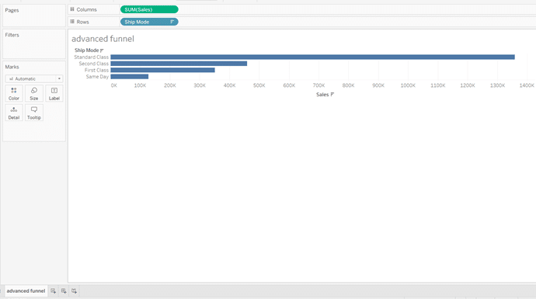
- Step 2. Now, convert this horizontal chart into an Area chart from the dropdown menu under the Marks section.
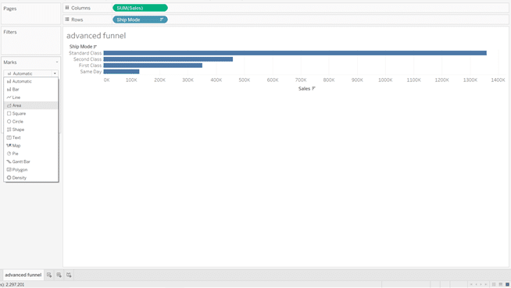
- Step 3. Also, resize your Area chart by changing the View option from Standard to the Entire View.
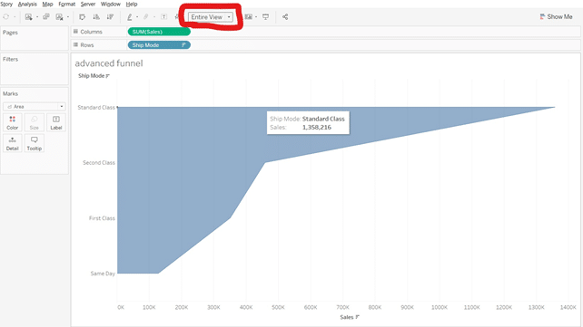
- Step 4. The above visualization only shows the half or the positive part of the funnel chart. This is because the negative data values for the negative part are not present in the dataset. Therefore, we have to add those negative values based on the present data values.
- Step 5. For that, we’ll create a calculated Field from the Profit dropdown menu>> Create>> Calculated Field.
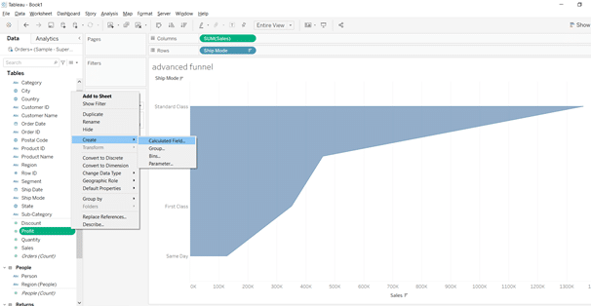
- Step 6. A dialog box will appear where you can name your calculated field and apply different formulas. Here, you have to write ‘-[Profit]’ as shown in the screenshot below, apply the changes and click on the OK button.
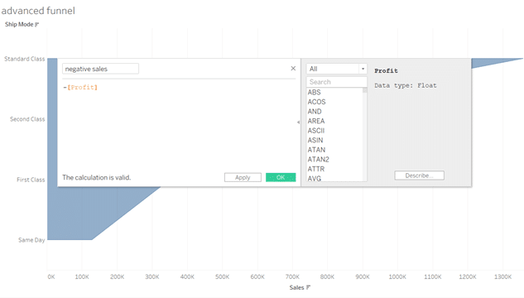
- Step 7. A dimension named negative sales will be added in the tables section. Now, drag the negative sales and drop it in the columns section. The entire funnel chart will be created on the interface.
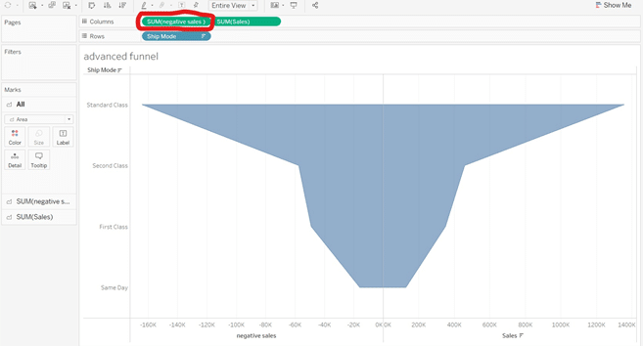
- Step 8. Drag and drop the dimension Ship Mode as labels in the Marks section.
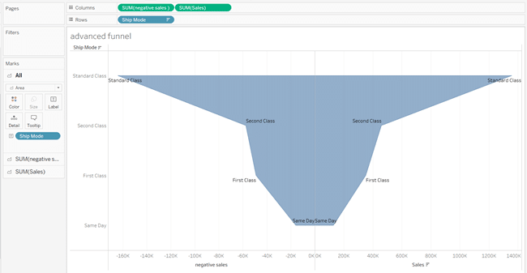
- Step 9. On the tableau, you can also add differences in each part of your smooth funnel chart. To do so, click on the Sales label and remove the Ship Mode label from it.
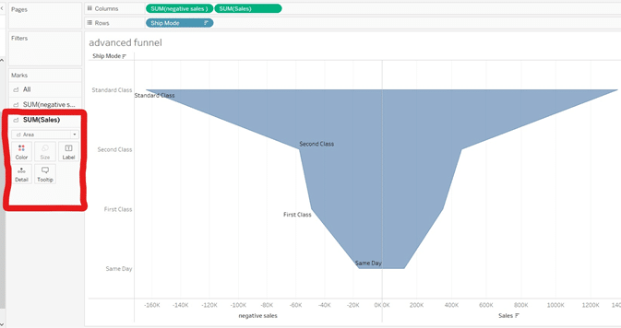
- Step 10. Now, you can add any other field like Sales Percentage to the positive part of the tableau funnel chart.
- Step 12. Simply, drop the Sales field in the SUM(Sales) label and select SUM(Sales)>> Quick Table calculation>> Percent of Total
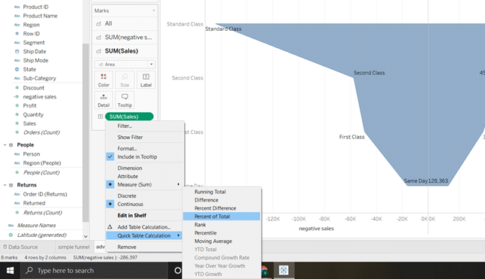
- Step 13. The Sales value will change from numerics to a percentage. You can also change the color of each part of the funnel from the Colors field in the Marks section.
